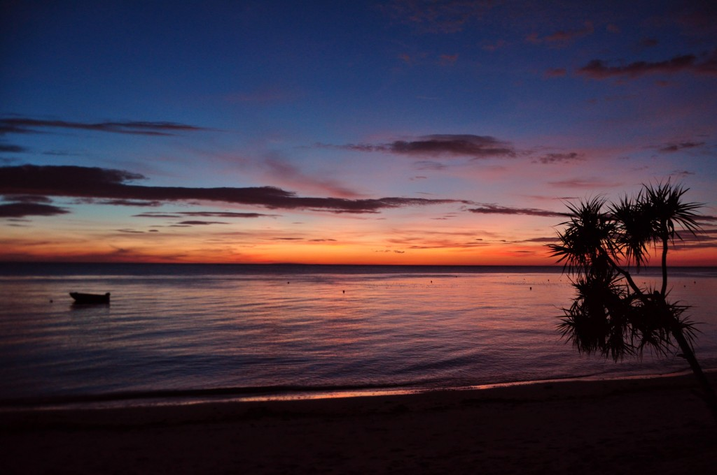

Waiver



The Laguna Adventure Project

**Participant's Name:** _________________________

____________on _____________

**Waiver of Liability, Assumption of Risk, and Indemnity Agreement**

**Waiver:** In consideration of being permitted to participate in any way on the ________________

,hereinafter called "Activity", I, for myself, my heirs, personal representatives or assigns, **do hereby release, waive, discharge, and covenant not to sue** the organizers of the activity **from liability from any and all claims** resulting in personal injury, accidents or illnesses (including death), and property loss arising from, but not limited to, participation in Activity.

**________________________ ____________ ________________________ ____________**

**Signature of Participant Date Signature of Parent of Minor Date**

**Assumption of Risks:** Participation in Activity carries with it certain inherent risks that cannot be eliminated regardless of the care taken to avoid injuries. The specific risks vary from one activity to another, but the risks range from 1) minor injuries such as scratches, bruises, and sprains to 2) major injuries such as eye injury or loss of sight, joint or back injuries, heart attacks, and concussions to 3) catastrophic injuries including paralysis and death.

**I have read the previous paragraphs and I know, understand, and appreciate these and other risks that are inherent** in Activity I hereby **assert that my participation is voluntary and that I knowingly assume all such risks.**

**Indemnification and Hold Harmless:** I also agree to INDEMNIFY AND HOLD the organizers of the

Activity HARMLESS from any and all claims, actions, suits, procedures, costs, expenses, damages and liabilities, including attorney’s fees brought as a result of my involvement in Activity and to reimburse them for any such expenses incurred.



The Laguna Adventure Project

**Severability:** The undersigned further expressly agrees that the foregoing waiver and assumption of

risks agreement is intended to be as broad and inclusive as is permitted by the law of the Republic of

the Philippines and that if any option thereof is held invalid, it is agrees that the balance shall, not withstanding continue in full legal force and effect.

**Acknowledgment of Understanding:** I have read this waiver of liability assumption of risk and indemnity agreement, fully understand its terms and understand **that I am giving up substantial rights including my right to sue**. I acknowledge that I am signing the agreement freely and voluntarily and intend by my signature to be a complete and unconditional release of all liability to the greatest extent allowed by law.

**________________________ ____________ ________________________ ____________**

**Signature of Participant Date Signature of Parent of Minor Date**

Participant's Age (if minor) ___________

Waiver