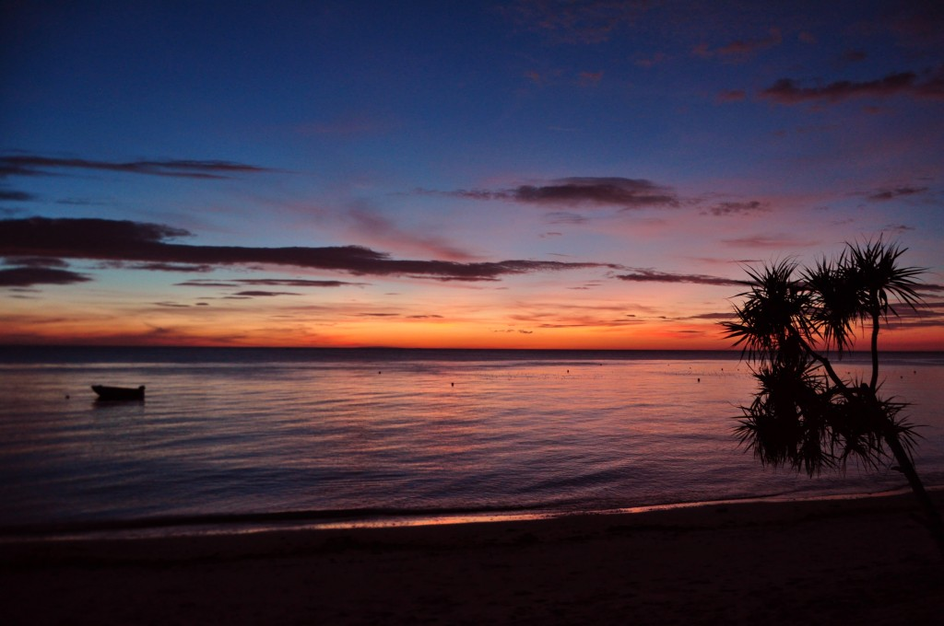



The Laguna Adventure Project

**Key Contact Person Information:**

**Tour Dates:** ________________ **Destination:** ________________________

**Full Name:** (Mr./Mrs./Ms./Dr.) ______________________________________________________

**Home Address:**  _______________________________________________________________________________

**Company Name:** _______________________________ **Title/ Position:** __________________________

**Address :** _______________________________________________________________________________________

**Phone:** Mobile #: __________________________________ Home / Office #: __________________________

**Email Address:** Home**:** _____________________________________________

Office: _____________________________________________

**Personal Details:** **Age:** ________ **Gender:** ________ **Marital Status:** __________________

**Physical Limitations:** ____________________________________

____________________________________

**Healthcare Provider:** ____________________________________ **Phone:** _____________________

**Healthcard Policy Number :** ____________________________

*Please list name(s) & telephone number(s) of person(s) to contact in case of emergency:*

________________________________________ __________________________________________

________________________________________ __________________________________________

**Additional Participants’ Information:**

|  |  |  |  |  |
| --- | --- | --- | --- | --- |
| **Name** | **Gender** | **Age** | **Mobile Number** | **Email Address** |
| **1.** |  |  |  |  |
| **2.** |  |  |  |  |
| **3.** |  |  |  |  |
| **4.** |  |  |  |  |
| **5.** |  |  |  |  |
| **6.** |  |  |  |  |
| **7.** |  |  |  |  |
| **8.** |  |  |  |  |
| **9.** |  |  |  |  |
| **10.** |  |  |  |  |
| **11.** |  |  |  |  |
| **12.** |  |  |  |  |
| **13.** |  |  |  |  |
| **14.** |  |  |  |  |

Date: ___________________ Signature: _________________________

Adventure Registration Form



Adventure Registration Form

The Laguna Adventure Project



**Payment Terms:**

Deposit of **50%** of the total amount per person is due within **5 days** from the time the registration form was received by the *Participant/s.*

The balance of the total tour cost is due upon departure.

*Participant/s* who do not pay the required down payment during the prescribed time frame will have their slots forfeited.

**Bank Information :**

|  |  |
| --- | --- |
| **Philippine Peso Account** | |
| **Bank** | **Banco de Oro/BDO** |
| **Account Type** | **Savings** |
| **Account Number** | **001570362708** |
| **Account Name** | **Ester B. Barrameda** |

**After the Payment has been made :**

Once payment has been made through bank, *Participant/s* is/are expected to send a copy of the deposit slip with the accomplished Adventure Registration Form to [***thelagunaadventureproject@yahoo.com***](mailto:thelagunaadventureproject@yahoo.com).

Upon receiving the filled out form, **Adventure Confirmation** will be sent to the Participant/s through email.

***NOTE :*** *By sending the accomplished and signed Adventure Registration Form with the bank deposit slip,*

*Participant/s agree/s to the Terms and Conditions and Waiver Policy stipulated hereon.*

**Signature:** _________________________ **Date:** ______________________________